Assignment 7

1)Write a query that counts all orders for October 3.



2)Write a query that counts the number of different non-
NULL city values in the Customers table.

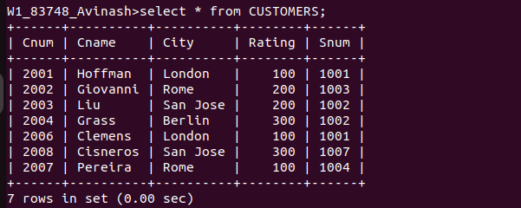

3) Write a query that selects each customer’s smallest order.
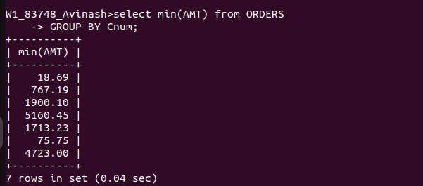

4) Write a query that selects the first customer,
in alphabetical order, whose name begins with G.

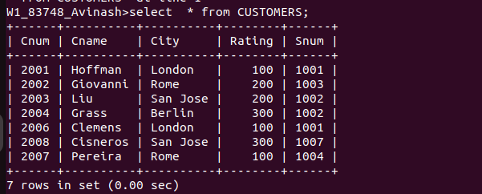

5) Write a query that selects the highest rating in each city.
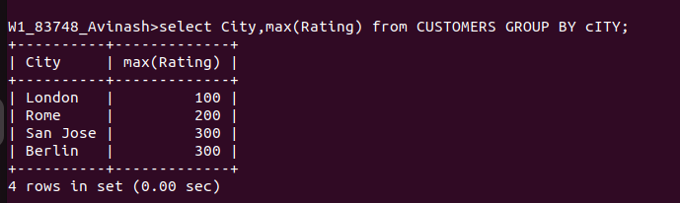

6)Write a query that counts the number of salespeople
registering orders for each day. (If a salesperson has more
than one order on a givenday, he or she should be counted
only once.).

